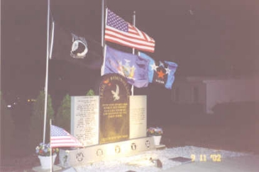
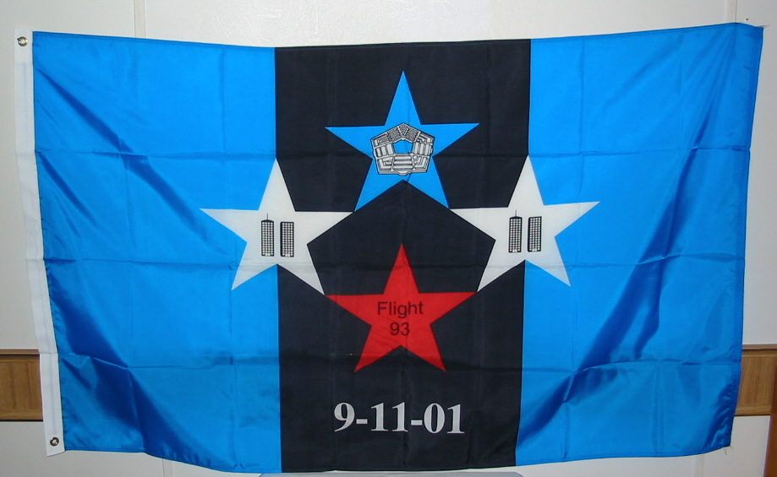
9/11 National Remembrance Flag

Ordering Information

Flag items may also be ordered directly from our web page
www.911remembranceflag.com
(payment via PayPal)
Or you can order the items by filling in the information below and mailing this form and your check to:
9/11 National Remembrance Flag
9348 Ridge Road
North Rose, NY 14516
Questions: please call (315) 573-2292
Or e-mail: 911nrf@rochester.rr.com
Please make checks payable to:
9/11 National Remembrance Flag
or (9/11 NRF)

Shipping Information:
Name: _____________________________
Address: ___________________________
___________________________________
ALL ITEMS ARE MADE IN THE U.S.A.

Qty Item Cost Total

___ 3’x5’ flag $40 _____

___ 4”x6” flag $5 _____

___ 4”x7” sticker $2.50 _____

___ lapel pin $3.50 _____

___ 1¼”x3” sticker $1 _____
(hardhat size)

____ Italian charm $5 _____

___ 2 ¼”x4” Patch $5 ____

ORDER TOTAL = $ _____

All costs INCLUDE sales tax, shipping & handling
Canandaigua Trail of Remembrance

What the flag represents:
The background

The blue on each side of the flag represents the color of the state flags for each state where a plane was downed - New York, Pennsylvania & Virginia.
The black in the center of the flag represents the sorrow we feel for the innocent lives lost from this tragedy: those on the planes, those working in the towers, the Pentagon, and the rescue workers that lost their lives during the rescue.

The stars

The stars represent the 4 planes that crashed and the innocent lives lost on those planes and in the buildings.
The blue star represents the Pentagon & American Airlines Flight 77, and for the innocent passengers and the lives lost in the Pentagon.

The 2 white stars represent each of the towers at the World Trade Center, American Airlines Flight 11 and United Airlines Flight 175, the innocent passengers on those flights, the lives lost (both those in the buildings and the rescue workers) and those that survived.
The red star represents United Flight 93 that crashed in Shanksville, Pennsylvania, the innocent passengers, and those who sacrificed their lives to protect the loss of other innocent lives.

The color of the stars (red, white & blue) is representation of our United States flag.

All 4 stars are touching, as well as the 2 white stars to touch the blue in the flag - this represents our 'unity' in the United States.

