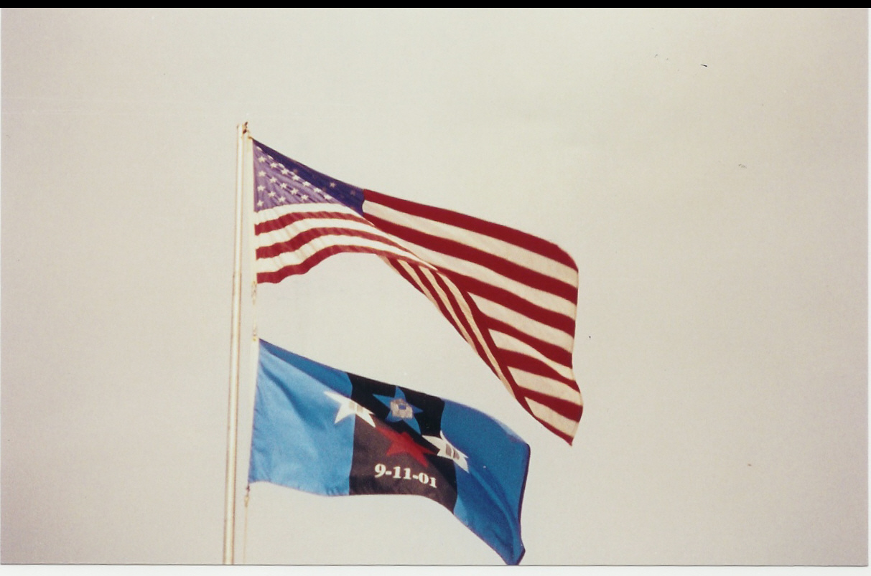
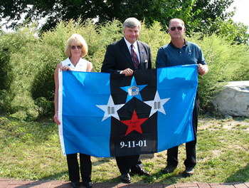

History on the 9/11 National Remembrance Flag

Following the tragedy that struck our nation on 9/11/01, we like thousands of other Americans wondered what we could do to help. We knew that a monetary donation would be appreciated, but felt compelled to do something more. It was just a few days after the 11th, that two news commentators were speaking of the tragedy, and relating it to Pearl Harbor. It was disheartening to hear them say they did not recall the date of the attack (12/7/41). Not too far down the road after hearing this, was a POW/MIA flag flying (a flag which has always been very meaningful to us).
It was a combination of the above, along with our desire to do something to help that brought us to the idea of creating the remembrance flag. We felt the creation of a flag would provide an everlasting remembrance to the innocent lives lost. Further, we felt that selling them would provide many people the opportunity to share in displaying their remembrance to the lives lost, as well as the proceeds providing ongoing donations to the various relief efforts.
In designing the flag, we wanted to insure that we respectfully and equally represented each site where a tragedy had occurred that day - thus the center stars holding a silhouette of the Pentagon and Twin Towers; and the words "Flight 93". We also wanted to include a portion of the flag that would express everyone's sorrow. This is the portion of you reaching out to the victim's families. The black in the center panel of the flag represents this. The two blue panels are the colors of the state flags where each plane was downed: New York, Pennsylvania & Virginia. The color of the stars: (red, white and blue) is representation of the colors in our United States Flag.

Once the design was drafted on the computer, we looked through hundreds of other flag designs to insure there were no conflicts of designs with any other flags. We filed for copyright on 9/25/01. Being two individuals, not a company, the time from conception to actual manufacture of the flags was a long road, but eventually, the flags were available to the public.
The first flags were received from the manufacturer in August, 2002.

Proceeds from the Sale
of the flag go to various relief efforts related to 9/11/01.

Your purchase will help in our efforts to provide continuous funding to these relief efforts. In addition, displaying your flag will help to insure that we shall never forget the innocent lives lost nor the families they left behind.

Purchase a flag item and give twice:

If you purchase a flag as a gift for a loved one, you not only give to them, but provide funding to a relief effort in memory of loved ones lost on 9/11/01.

Our sincere thanks to all who have supported our efforts. We could not do it without your help.

Steve & Joanne Galvin

Joanne Galvin, Senator Michael Nozzolio, Stephen Galvin
9/11 Flag proudly displayed under the US Flag

